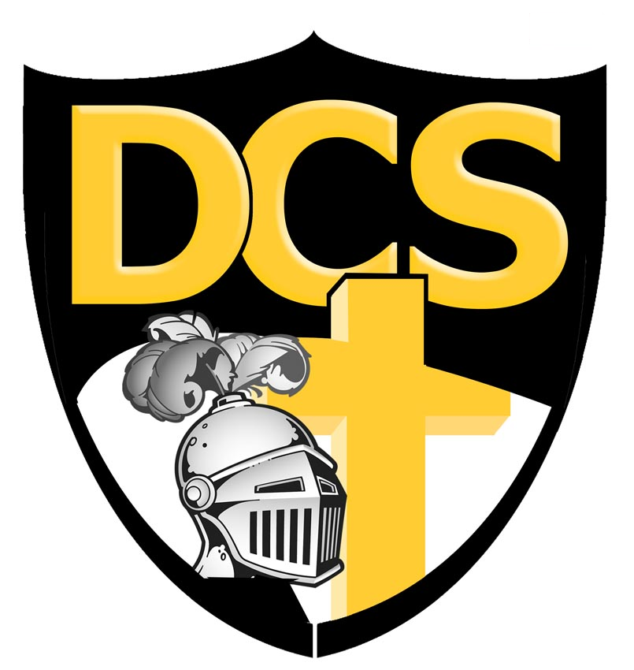
Dakota Christian School
37614 SD Hwy 44, Corsica, SD 57328
Phone 605-243-2211 • Fax 605-243-2379 • Website: www.dchs.net • Principal’s E-mail dcsprin@dchs.net

Dakota Christian School
Board Meeting Minutes
July 8th, 2024, 7:30 p.m.

- Opening devotions by Anthony DeHaan
- Roll Call - Present - Paul Baas, Steve Randall, Anthony DeHaan, Aaron Timmerman, Traci Niewenhuis, Corey Vander Pol, Randy Veurink, Mitch Vander Pol, Cassie Erickson, Mitch Munneke, Jared Peters.
- Motion made and supported to accept June board meeting minutes. Motion passed.
- Correspondence – none
- Committee Reports and Business
- Finance
- Motion supported to pay June bills. Motion passed.
- Education – none
- Buildings and Grounds
- Motion made and supported to improve the landscaping in front of the school. Motion passed.
- Promotion – none
- Transportation – none
- Co-op
- Motion made and supported to the agreed upon changes made in the Co-op agreement. Motion passed.
- Hudl - Discussion
  - $8,500 for one year - including two cameras
  - Possibility to lock cost when signing a 3 year contract
  - Motion made and supported to sign a one year contract for Hudl, splitting cost with Lake Andes. Motion passed.
- Principal’s report given for information
- Discussion of switching the year book to a digital form with the option to order a hard copy if wanted.
- Report given on the virtual job fair.
- Old Business
    - Interior painting over summer (2023) including offices, staff room, music room was never completed. Board members plan to complete this painting before school starts.
- New Business
- Teacher search update
  - Still looking for a kindergarten teacher, secondary Math teacher, secondary Social Studies teacher
- Motion made and support to offer Traci Niewenhuis the assistant AD contract for the 2024-2025 school year. Motion passed.
- Assistant AD job description
      - Policy 911. Added Assistant AD job description to policy 911.
- Second reading Policy 544
- Set school board meeting dates for 2024-2025
- Second Monday of the month at 7:30pm, time changes to 7:00pm from November to March
- New board member orientation will be next meeting
- School Visitors
    - Will start in September
- Executive Session
- Motion made and supported to enter executive session at 2029. Motion passed.
- Motion made and supported to exit executive session at 2034. Motion passed.
- Closing prayer lead by Mitch Munneke

