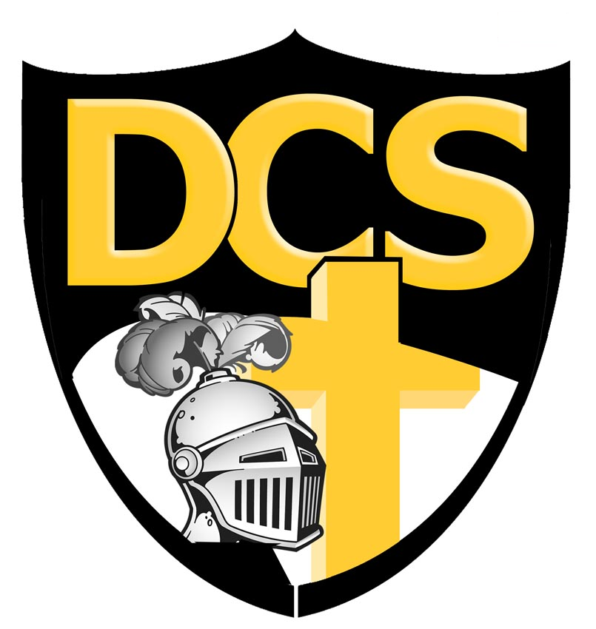
Dakota Christian School
37614 SD Hwy 44, Corsica, SD 57328
Phone 605-243-2211 • Fax 605-243-2379 • Website: www.dchs.net • Principal’s E-mail dcsprin@dchs.net

Dakota Christian School
School Board Meeting
April 26, 2024 7:30pm
I. Opening prayer by Paul Baas
II. Roll Call: Paul Baas, Mitch Vander Pol, Corey Vander Pol, Cassie Erickson, Randy Veurink, Anthony DeHaan and Traci Niewenhuis. Mitch Munneke and Aaron Timmermans absent with notice.
III. Motion made and supported to pay the second semester tuition aid. Motion passed.
IV. Executive session
a) Motion made and supported to enter executive session at 1943. Motion passed.
b) Motion made and supported to exit executive session at 2126 . Motion passed.
V. Corey Vander Pol closed with prayer.

