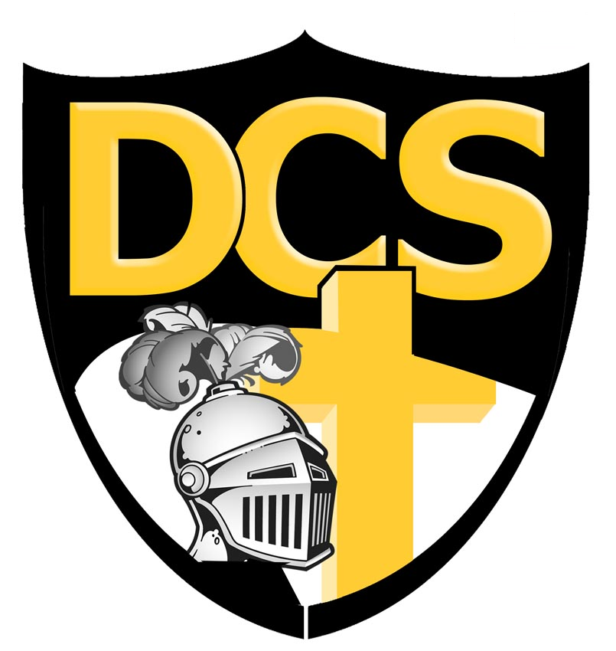
Dakota Christian School
37614 SD Hwy 44, Corsica, SD 57328
Phone 605-243-2211 • Fax 605-243-2379 • Website: www.dchs.net • Principal’s E-mail dcsprin@dchs.net

Dakota Christian School
School Board Meeting
April 22, 2024, 7:30pm
- Opening prayer by Paul Baas
- Roll Call: Paul Baas, Mitch Vander Pol, Aaron Timmermans, Corey Vander Pol, Mitch Munneke, Cassie Erickson, Randy Veurink, Anthony De Haan. Traci Niewenhuis absent due to a conflict of interest.
- Executive session
  - Motion made and supported to enter executive session at 1938. Motion passed.
  - Motion made and supported to exit executive session at 2100. Motion passed.
- Motions
  - Motion made and supported to offer Traci Niewenhuis teaching contract for the 2024-2025 school year. Motion passed.
  - Motion made and supported to offer Abby Smikle the full-time head teacher contract for the 2024-2025 school year. Motion passed.
  - Motion made and supported to offer Mr. Peters the CEO contract for the 2024-2025 school year. Motion passed.
- Buildings and grounds
  - Motion made and supported to install new lighting in the music room and home girl’s locker room. Motion passed.
  - Motion made and supported to install rock by south-east playground door. Motion passed.
- Aaron Timmermans closed with prayer.

